BadgePass HD Identity Camera

Introduction

Thanks for purchasing the BadgePass HD, BadgePass newest entry into the high end photo-ID and visual database application imaging.

The BadgePass HD provides full HD resolution at 1080x1960 and includes a synchronized photoflash for consistent high quality image acquisition in any environment. Software controls are provided for flash intensity and color adjustments making the acquisition of top quality images a snap. High quality captures with perfect skin tones and exposure can be obtained effortlessly in any environment, even very dark room!

Features Include:
- Full HD+ Resolution 1080x1960
- Superior low light performance even without flash allowing for top quality captures in even the harshest environments.
- 25-1 Optical Zoom
- USB hardware interface
- Integrated high intensity photoflash with software control of flash exposure and flesh tones. Perfect captures even in dark rooms.
- Extensive User control of Image Size, Cropping, and Color adjustments.
- Optics configured for Portrait mode captures not Landscape allowing for the highest resolution in the format of your ID Badge layout.
- Includes Twain Driver, Standalone App, and Optional 32&64 bit SDK
- Will work in all major Windows® photo ID and imaging applications.
- Phone or E-mail support for the lifetime of the product.

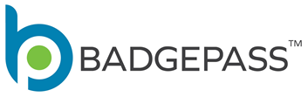

Provided in this manual are instructions for hardware and software installation, as well as operational guides and tips.

If technical support is needed please contact:
www.badgepass.com

Parts List for available BadgePass HD products:

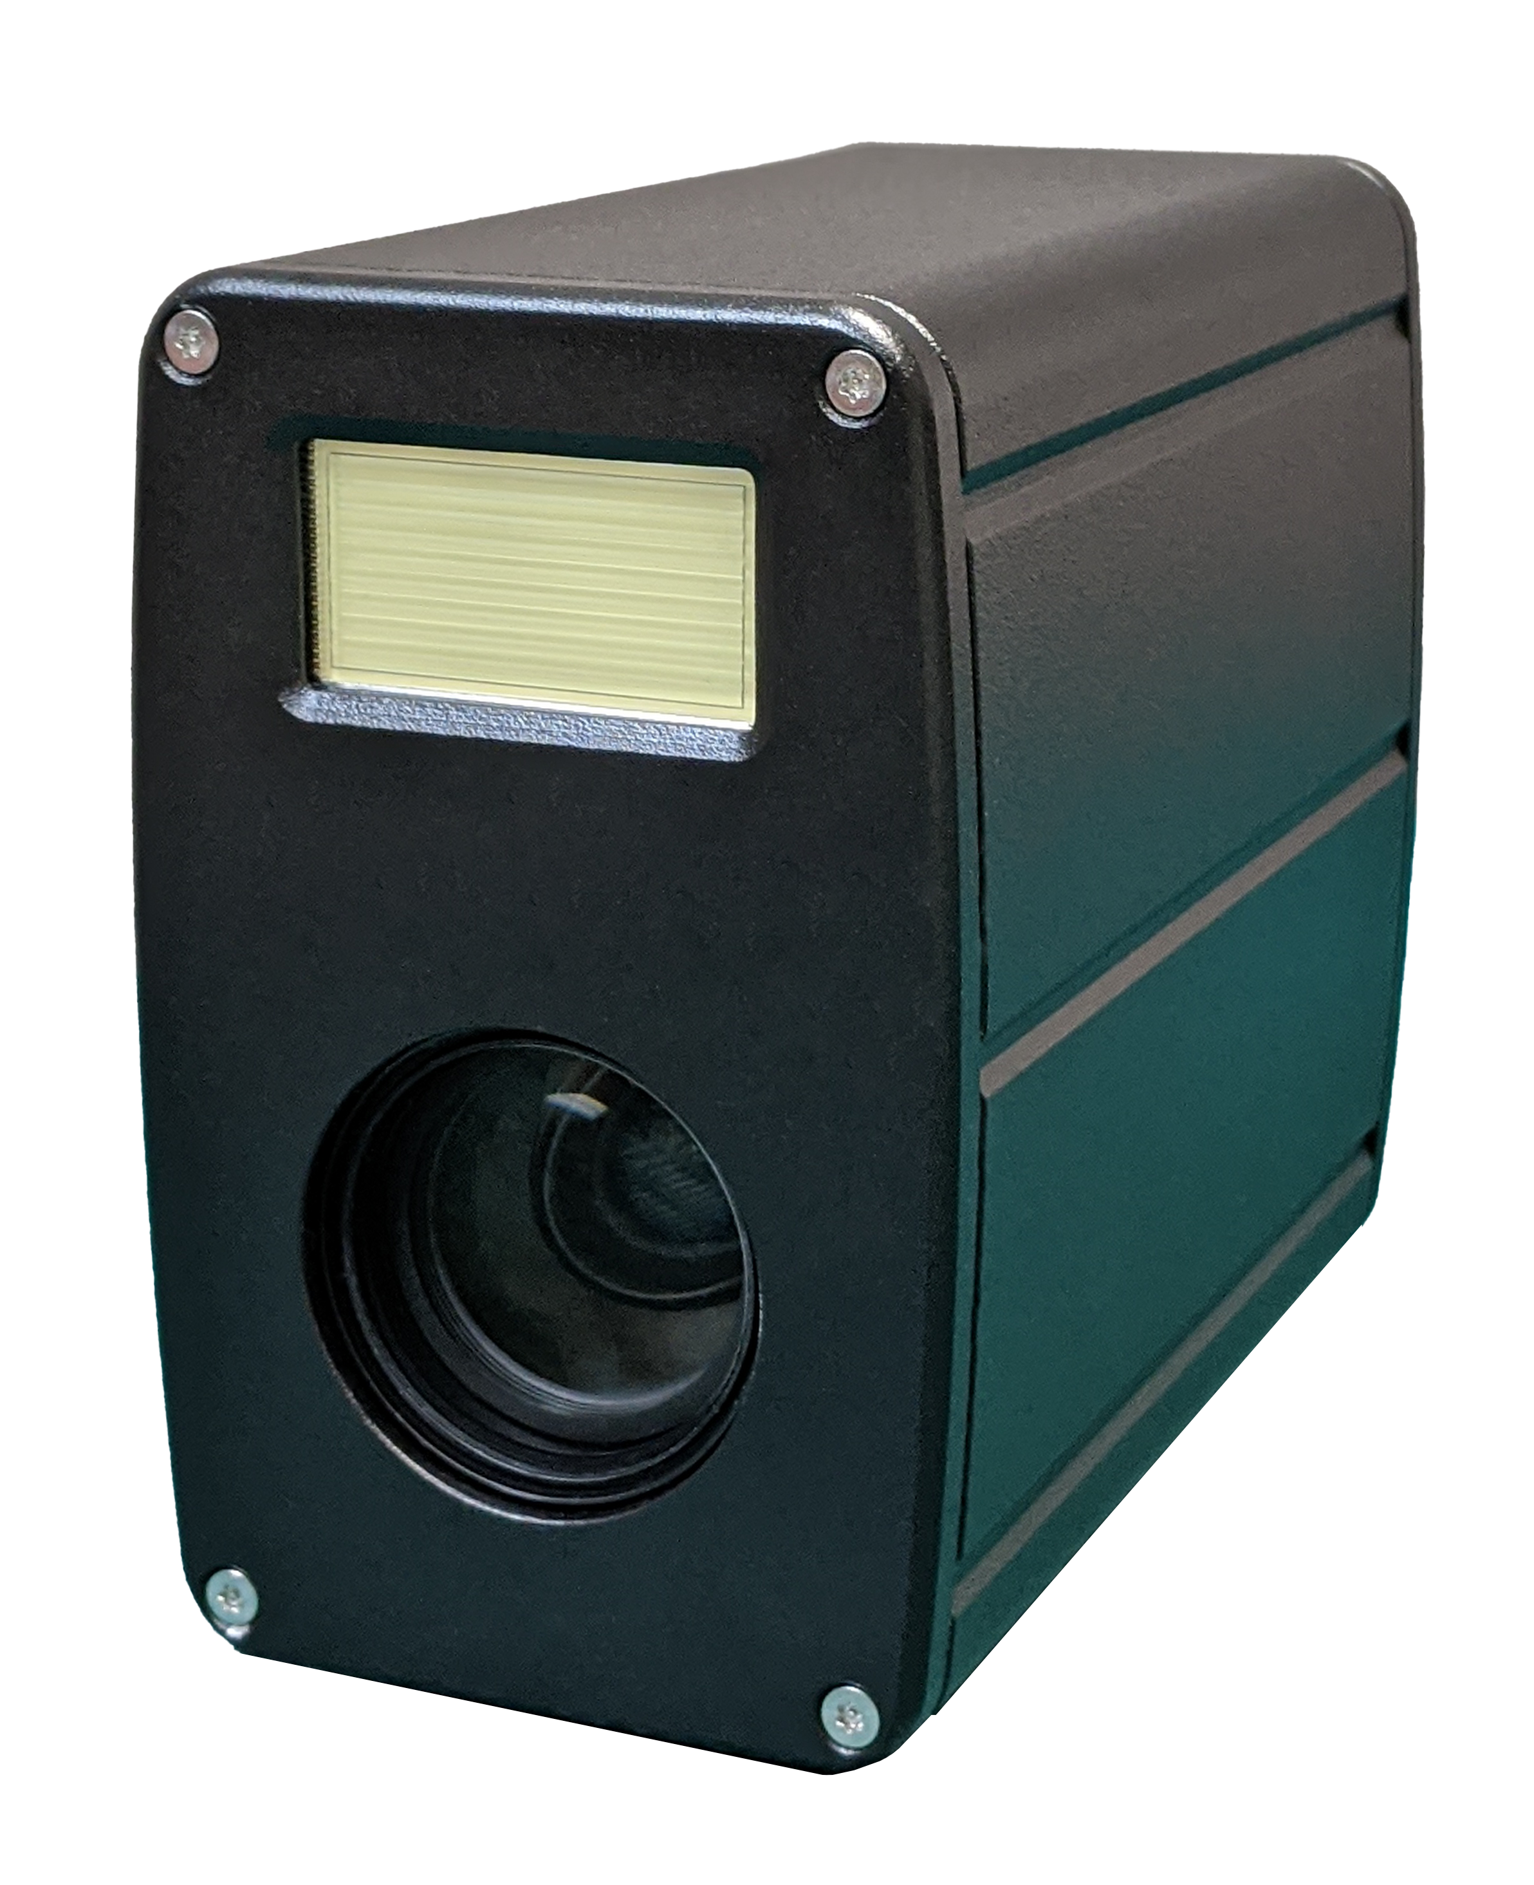
BadgePass HD Identity Camera

High resolution USB Zoom camera
USB 3 10ft cable
Brick power supply for camera w/extension
Instruction Manual
Software

Installation for BadgePass HD to Win 7,8,10, or Server edition computer.

- Run Setup_BadgePass_HD_Identity_Camera_version number.exe located on the installation CD (or) USB Thumb Drive (or) Downloaded from the internet

- During Installation of software your computer may prompt you asking if you want to install software from Video Associates Labs, select Yes

*Note: Do not connect the camera to the computer until after software installation.

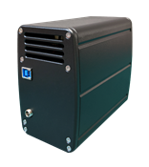
- Connect the power adaptor to the matching connector on the back of the camera. Plug the power adaptor to a wall socket.

- Connect the USB cable to the back of the camera.
Do not connect the USB cable to the computer unless you have installed the software.

- The computer will find new hardware and install the device. Answer Yes or Continue if you are queried during the installation.

- You can confirm the installation by opening Device Manager (type Device Manager in the search bar to find the application) and noting the “BadgePass Identity Camera” listed under “BadgePass Identity Camera” entry.

NOTE: When upgrading software ALWAYS UNPLUG THE POWER SUPPLY CONNECTOR before installing the new software. Plug in the Power Supply Connector after the software upgrade is installed. Camera firmware will not be upgraded unless this procedure is followed.

Basic Operation

- Click on START-->BadgePass HD Identity Camera->BadgePass HD Identity Cameraand start the application.

- The BadgePass HD capture control box will appear. If you receive an error message or the capture control box does not appear displaying live video please verify that the BadgePass Identity Camera appears in the device manager under “BadgePass Identity Camera” entry.

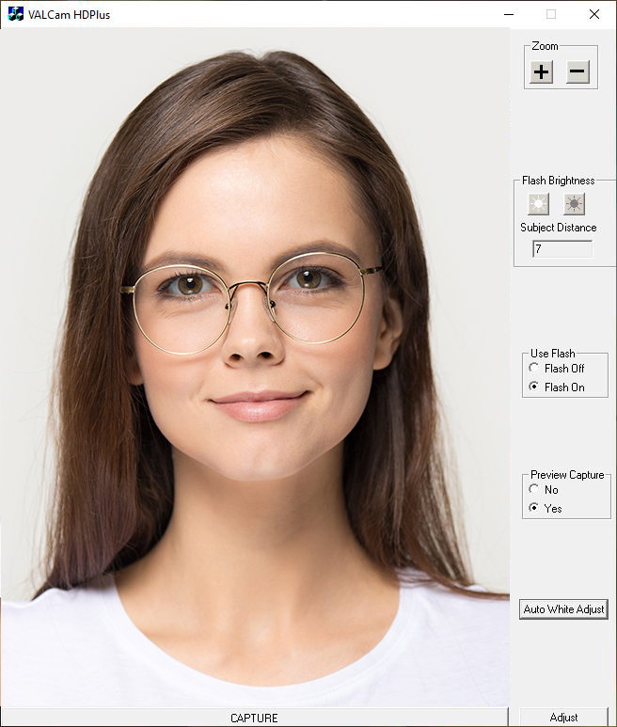

Camera Zoom controls
- Place the mouse curser over the “+” or “-“button located in the Zoom box of the Main Application window and left click on it. You can hold it down to continuously zoom or click it for smaller adjustments.
- To control Zoom from the keyboard you can press the + key next to the numeric keypad, the camera will zoom in. Release the + key and the camera will stop zooming. To zoom out press the – key next to the numeric keypad. Release the – key to stop the action.

- To speed up the Zooming action hold down the Ctrl key when activating Zoom.
To slow down the Zooming action hold down the Shift key when activating Zoom.

- To adjust the default zoom speed of the camera click on the Adjust button then click on the “Flesh Tone” tab. The “Zoom Speed” box is located at the bottom of the tab and has 3 radio buttons for Zoom Speed settings.

Sharpness Control

- Click the “Advanced” tab on the Adjust Dialog box.

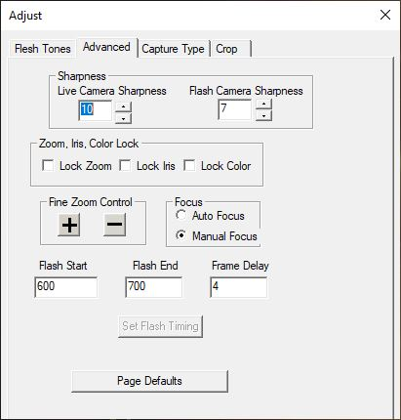
- There will be Two different sharpness controls “Live Camera Sharpness” which only affects non-flash captures, the default is 10 and ”Flash Camera Sharpness” which only affects flash captures, the default setting is 7.

- Higher or lower values might be warranted in different circumstances. If the values are too high the image will look edgy and noisy. If the value is too low the image will look soft or out of focus.
- Clicking the “Page Defaults” button will restore
factory defaults.

Taking a Live (non-flash) Capture

The low light capabilities of the BadgePass HD are outstanding. It is possible that you will not even need to use the Flash mode to acquire top quality captures.
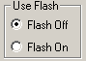

- On main dialogue box verify that the Use Flash is set to Flash Off and Preview Capture is set to Yes.
- Adjust the Brightness control buttons by clicking on them to incrementally lighten or darken the preview until you have optimal image illumination. This is the only control used to adjust image brightness.
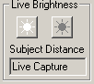
- The last setting of the Brightness control is remembered between sessions.

- Click the Adjust button and select the “Flesh Tone” tab.
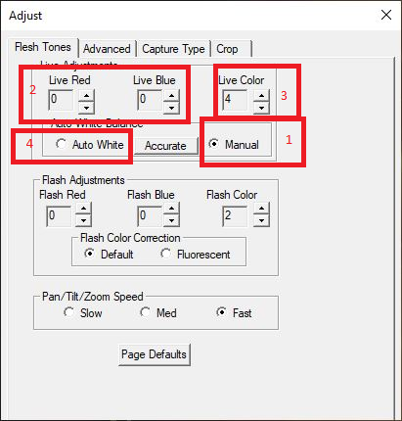
- Click the “Manual” radio button (1) to adjust the live preview colors.

Adjust the Live Red and Live Blue controls (2) up and down. Note the changes in the image color balance. These controls can be used to fine tune image color for optimal quality. These settings will be remembered between sessions.

*Note – In most cases you will not need to make these adjustments
- Adjust the Live Color control (3) and note the changes in the image. This control adjusts color intensity. The range is from 0-4 and the default setting is 4, if the color is too intense it can be lowered.
- To reset color adjustments click the “Auto White” (4) radio button.

Zoom should be set for a fairly tight shot of your subject.

NOTE: Because of the increased resolution of the HD Identity Camera this is not as crucial as it is with lower resolution cameras. Beware of being excessively zoomed out from your subject.
- After adjusting the Brightness, Flesh Tone, and Sharpness controls for best image quality click the Capture Button and the image will be displayed. The Preview is a smaller replication of the capture image.

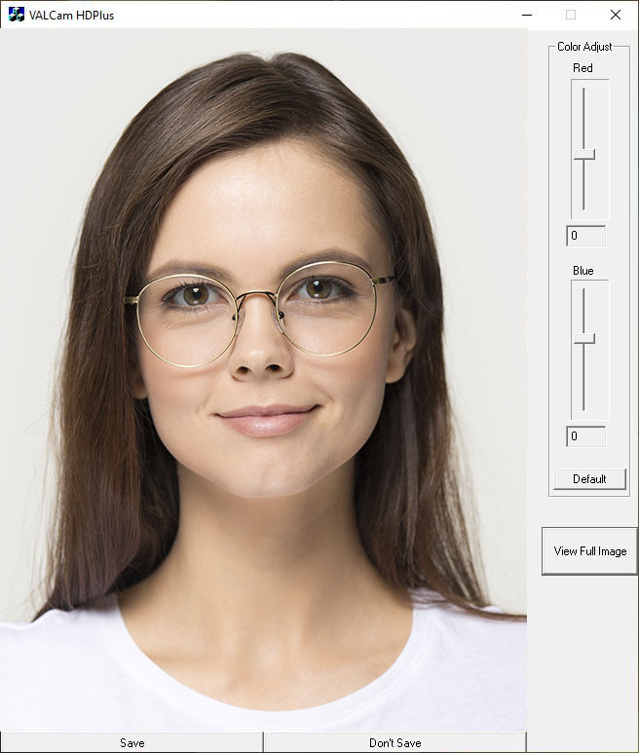

*Note- The image displayed is a scaled down version of the actual capture to fit in the User Interface. To view the full version of the Image captured click on the View Full Image button on the lower right of the preview image. If viewing the full image click on the “X” in the upper right to leave the image and return to the application.

- If you have already adjusted colors in the “Flesh Tone” Tab of the Adjust dialogue box as described on page 5, these settings will not need to be changed. It is recommended that you adjust colors for live captures in that method and that the Color adjust sliders be kept at the default settings of 0.

NOTE: When in the live capture mode typically these controls should be kept at a “zero” value and color adjustment should be done in the “Flesh Tone” tab of the Adjust box, these controls are more useful when taking Flash captures.

- Click the View Full Image button in the lower right side of the preview window to see a full scale version of the captured image that will be sent to your ID badging program. To return to the control screen click the “X” in the right hand corner.

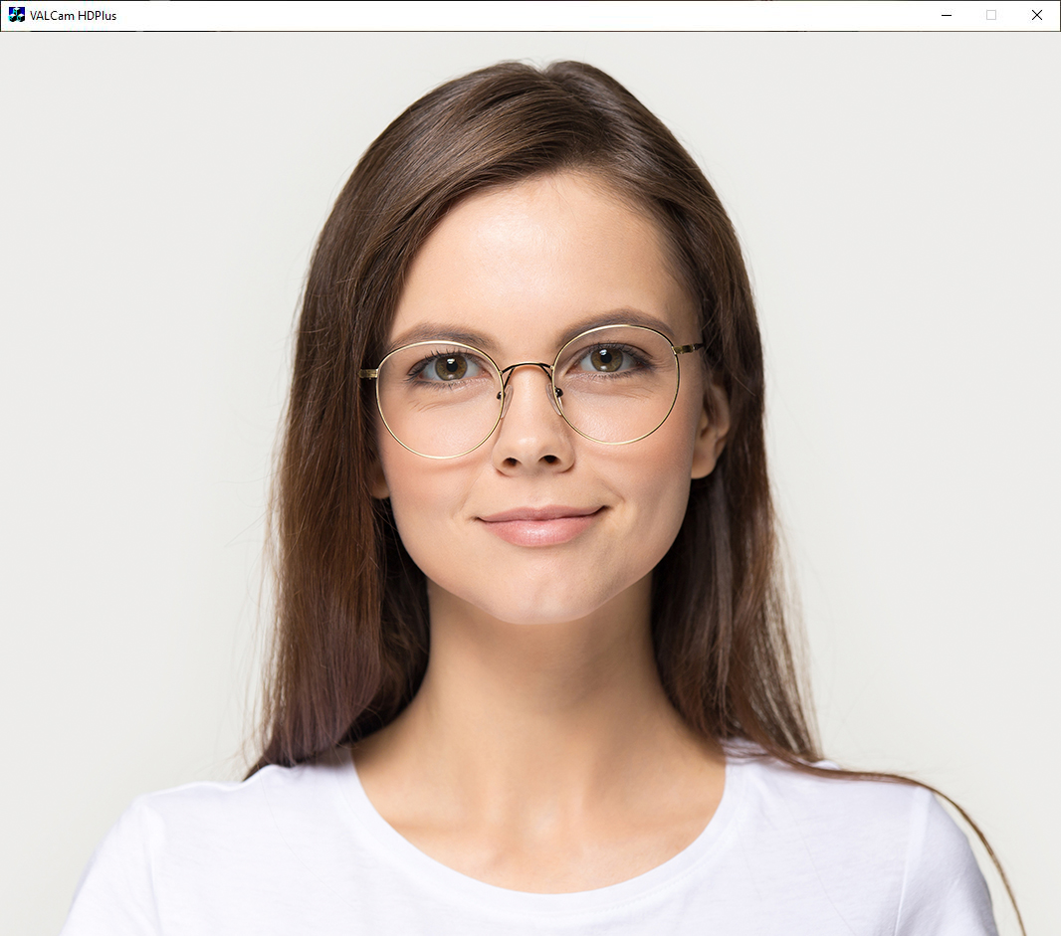

- Click the “Save” button to send the image to clipboard or your application. Click the “Don’t Save” button to discard the image and prepare to take another capture. This is very useful when using the Twain driver as you can immediately take another capture without restarting the Twain interface.

Using the Photo-Flash

The photoflash is a useful tool in demanding lighting environments, you can even take a capture in a completely dark room with little image degradation.

On initial setup the flash intensity should be set by using the Brighten and Darken buttons to optimize for your estimated camera to subject distance.
Once the flash intensity is set for a given subject distance this setting will not generally need to be changed even for various skin tones. If the subject distance changes this will need to be readjusted for the proper illumination.

Note: The BadgePass HD stores different settings for Flash and non-Flash captures so both live and Flash capture can be obtained without user intervention.

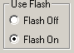
Taking a Flash Capture
- Click the Use Flash button to Flash On.
The Flash will be triggered the next time the capture button is clicked.

- Frame the subject with the camera controls.

Note: Remember to be conscious of zoom settings and avoid excessively wide settings for best captures.
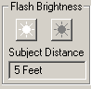
- Adjust the and buttons for the estimated subject distance from the camera. The button increases the illumination of the capture while the button decreases it.

*Note: The Subject Distance displayed is a guesstimate and should be fine-tuned by the results of your actual capture. Once set it should not have to be readjusted between subjects.

- Click the Capture Button and after a short delay the flash will fire and the image will be displayed. (Verify that Use Preview is set to Yes)

Flash set too dark Flash set too Bright
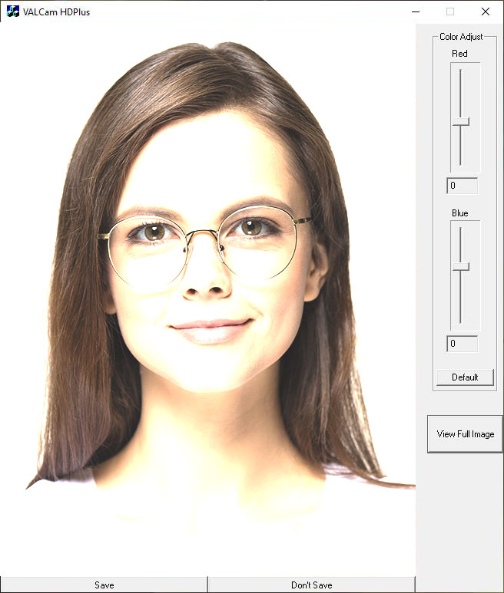
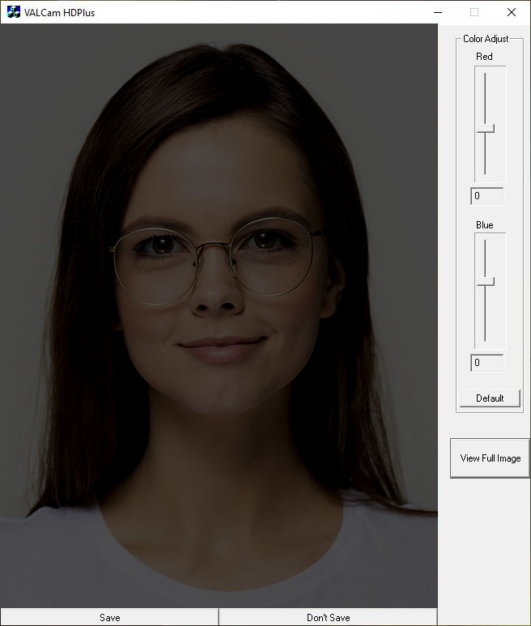
- Fine tune the and adjustments for optimal capture exposure and take another capture.
If the image is to dark click the Brighten button a couple of times and take another capture
If the image is to bright click the Darken button a couple of times and take another capture

- Repeat this process until optimal image exposure is obtained.

Note: The Brighter and Darker adjustments will not affect the Live Preview display when the Use Flash is set to Flash On.

Flash set correctly

- Once the proper setting is found it will only need to be readjusted if the distance changes from the camera to the subject.

Adjusting Flash Capture Quality

The color balance of the captured flash image can be adjusted in real time if needed. Any color changes made will be auto applied to further captures.
There are two methods for adjusting the color of the flash capture.

The first method and the easiest is to adjust the color on the main screen immediately post capture it is faster, more convenient, and will work for most applications.
The second method involves adjusting the colors prior to taking a capture and may offer better performance but is more difficult and time consuming.

Method 1 Post Capture
- After the capture, the image is displayed with the “Save” and “Don’t Save” buttons

- Red and Blue sliders appears next to the captured image the values can be adjusted from -50 to +50.
Positive values increase Red or Blue.
Negative Values decrease Red or Blue.

- To adjust the image increase the “Red” slider until the image appears too Red.
Decrease the “Red” slider until the image appears to be lacking in Red.
Then place the slider in the middle of that range

- Repeat this procedure with the “Blue” slider

- Iterate this procedure between both color bars until you have optimized the image

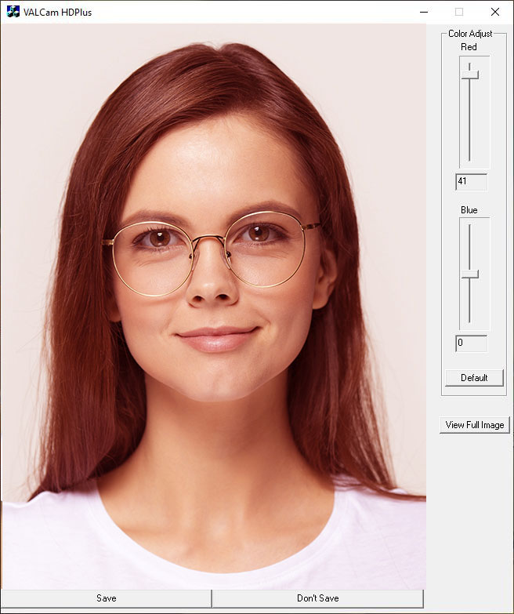
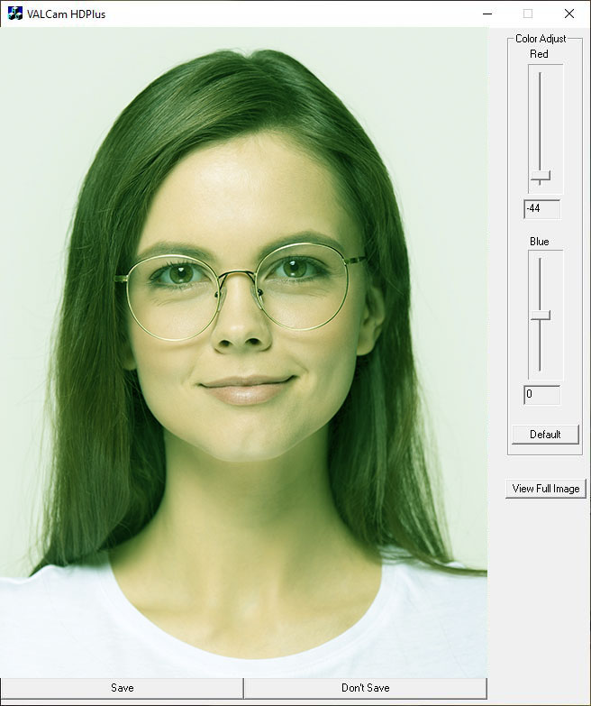
Too Much Red Too Little Red

Too Much Blue Too Little Blue
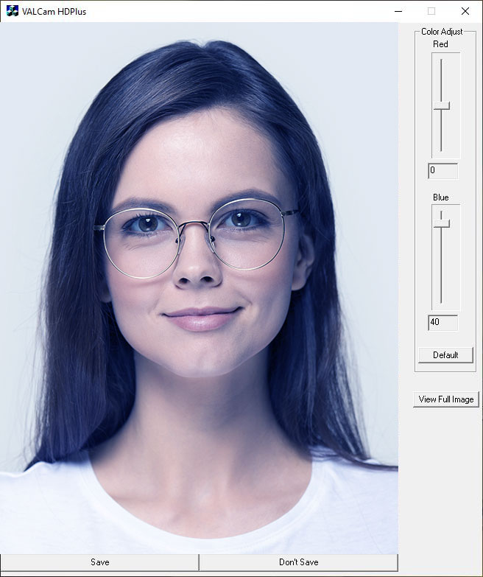
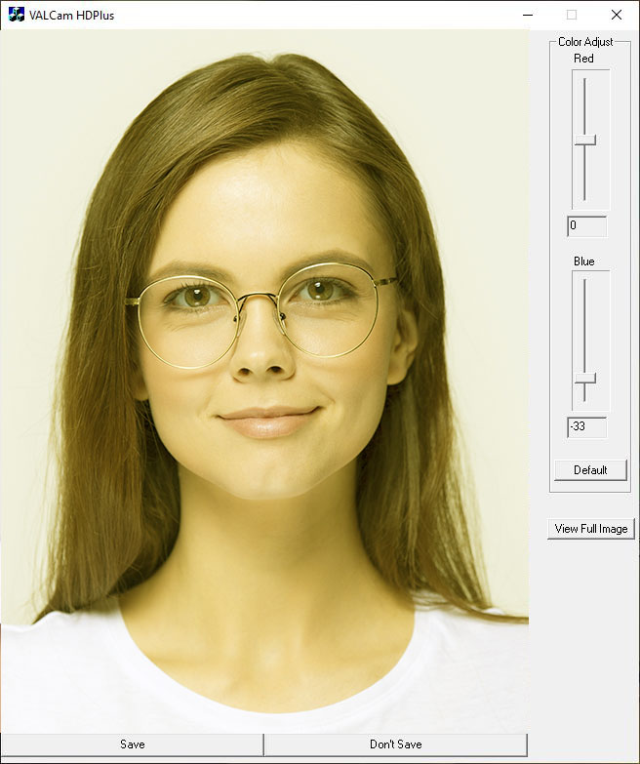
Note: Yellow skin tones indicates too little blue, so add blue to correct

- When finished you can click the View Full Image button to see a full sized image or Save the image.

Method 2 Pre-Capture
- This method is more difficult and time consuming.

- Click on the Adjust button to open the “Adjust” dialogue box and select the “Flesh Tone” tab

- Do not close the “Adjust” dialog box and take a flash capture.
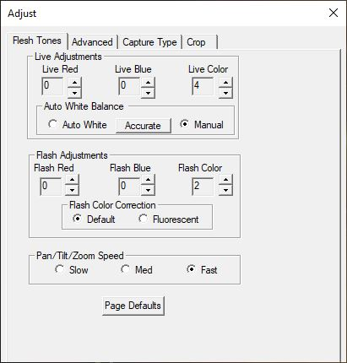
- Adjust the “Flash Red” and “Flash Blue” controls in the “Flash Adjustments” box for color balance
Take another capture to see the results of your adjustments

- Continue making fine adjustments and taking additional captures to see the results in the captured image.

Note: You have to take another capture to see the effects of your adjustments with this method.
- Please note that the Flash color controls only effect flash captures and have no effect on the live preview.

Cropping Control
The BadgePass HD allows the user to set cropping and sizing parameters that will be reflected in both the live preview and the captured image. Please be aware that the live preview display is a scaled down version of the capture, the cropping dimensions and the aspect ratio are maintained accurately. The captured image will be much larger but the same aspect ratio.

Optimally the aspect ratio (crop dimensions) of your capture should be set to match the aspect ratio of your ID card in your badging application.

Standard cropping dimensions can be selected. (4/5, 3/4, or 2/3) In addition a Custom option allows for any aspect ratio and size to be entered.

The size of the image can be reduced or increased 0% or 20% by selecting the appropriate radio button in the Image Size Reduction box to allow the live preview and full captured image to fit on your display. This can be helpful if using monitors with a lower screen resolution.

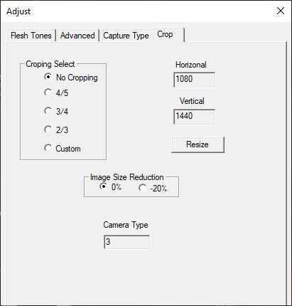
Using Cropping Control

- Click the Adjust button.
- Click the “Crop” tab on the adjust dialog box.
- Note the various options under “Cropping Select” click the various “Cropping Select” choices and see how the live display changes to the new aspect ratio.

*Note: Most ID programs use a 3/4 or 4/5 aspect ratio.

- Image Size Reduction – If you wish to reduce the Live Preview and final capture size.
*Note: Can be useful for systems with lower screen resolutions that the Live Display cannot accommodate.

*Note: Entering custom parameters will set the size of the Live Preview and the Captured Image.
- “Custom” selection allows custom entries for image size and aspect ratio if desired.

*Note: The actual pixel size of the image is displayed in the Vertical and Horizontal text boxes.

For Instance:
- Select the Custom radio button in the “Cropping Select” box
- To capture and image with an aspect ratio of 3/4 at a resolution of 675x900
- Manually enter the size dimensions (675 in Horizontal and 900 in Vertical)
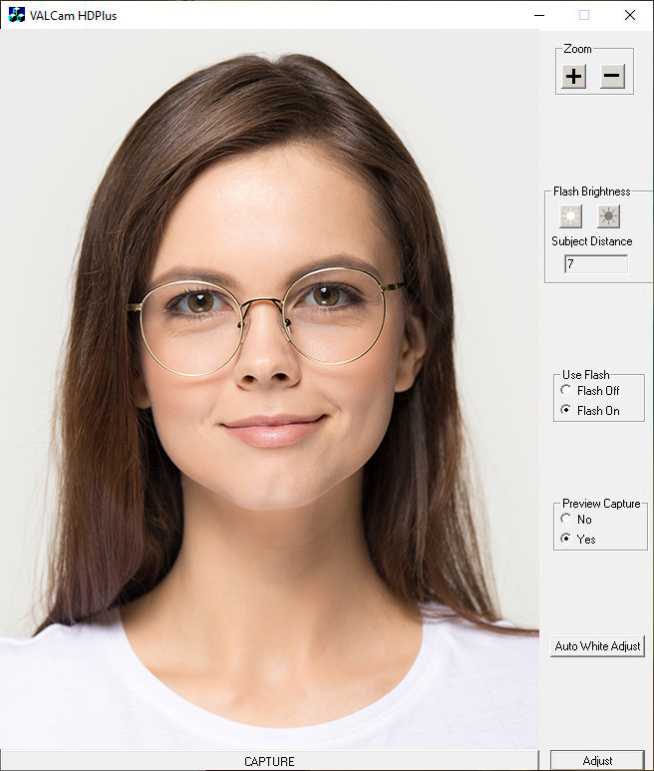
- Click the Resize button

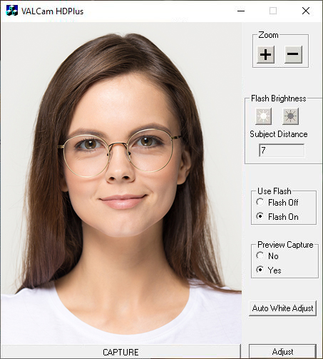
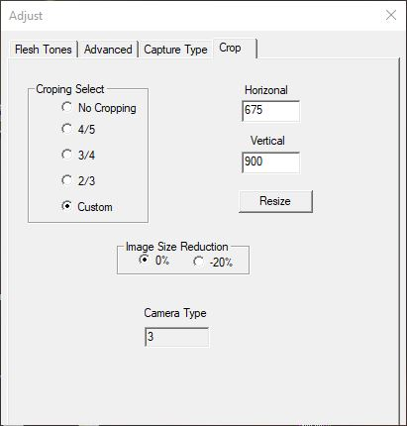
- Live Preview window is scaled down (it maintains the aspect ratio but is 1/2 the size of the captured image)
- Take a capture and then click the View Full Image button on the lower right side of the preview image to see the actual captured image in your custom size and aspect ratio.

*Note: Typically only the Horizontal/Vertical ratio of the camera settings need to match your card design. It’s not necessary to match absolute pixel values and usually undesirable to do so.
Using the BadgePass HD with Photo-ID Applications

Twain drivers for the BadgePass Identity Cameraare loaded during the software installation procedure. Using your application, select the BadgePass HD Identity Camera drivers as your Twain source.

Alternatively you can run the BadgePass HD Identity Camera executable as a standalone application and capture images directly to the Window’s clipboard or as a JPG file. You can then import these images into any applications.
We also offer a 32 & 64 bit SDK at no charge, please contact BadgePass for info if you are interested.

Saving a Capture Using the BadgePass HD Identity Camera Standalone App

You have multiple options to save your captures.

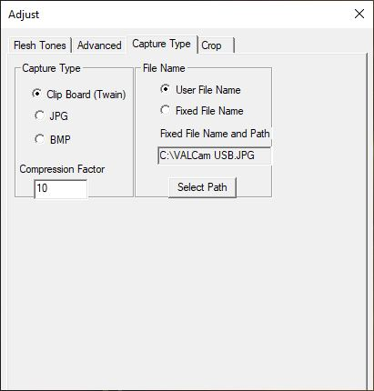
- To start click on the Adjust button in the main capture window.

- Click on the “Capture Type” tab.

- You will see 3 options in the “Capture Type” dialogue box that you select with the radio buttons beside them.
- Clip Board (Twain)
- Images saved on the Clip Board can be pasted in to any application (via CTL+V or selecting Paste after Right Clicking the mouse)
- This is the option that should be selected when using the camera as a TWAIN source.

- JPG
.
- Compression Factor controls the Image File Size and Quality of the saved Capture.
- The range can be set from 1-255
- A Higher number will result in a Smaller Image File Size but LOWER Image Quality
- Conversely a Lower number will result in a Larger Image File Size but with HIGHER Image Quality.
- Generally a Compression Factor under 25 will deliver very high quality image almost indistinguishable from the original capture.

Saving a JPG

- If you want to save as a JPG verify that “User File Name” is selected in the “File Name” box of the Capture Type tab.

- The location where the captures will be saved must be selected. Click the “Select Path” button.

- Navigate to a location using the File Explorer window to where you would like the captures to be saved and click Save.

*NOTE: The “File Name” in the Explorer window will be VAL Default.JPG DO NOT CHANGE THIS NAME

- The File Explorer Window will disappear.

- Go to the main camera application window (with the live preview image from your HD+) and click Capture

- Click Save

- A dialogue box will pop up and prompt you for a File Name to save the capture. Enter the desired name and click OK.

*Note: You do not have to enter the file extension when naming (.jpg) as the software will auto add that for you

Administrative Lock Options.

- The Flash, Zoom, and Color settings can be locked from the Adjust menu. This can be useful to assure that operators will not change the settings after they have been optimized
- Click the Adjust button
- The Adjust box pop up appears. Click on the “Advanced” tab.
- Locate the Lock Zoom, Lock Iris, and Lock Color check boxes.
- One settings are locked operators cannot make changes to these settings from the front panel control.
- If desired, a password can be set to only allow the Admin access to the Adjust dialogue box, see below for instructions.

Setting an Administrators Password

An administrative password can be applied to restrict using the Adjust dialog box. This prevents operators from changing parameters set up by the Administer.
The following parameters can be locked from end users:
- Zoom control
- Flash Intensity
- Preview adjustments
- Color adjustments
- Cropping parameters

Setting the Password:

- Type “Registry Editor” in the search field of the Task Bar
- Click on the Registry Editor App.
- Navigate to Computer\HKEY_CURRENT_USER\SOFTWARE\BadgePass HD Identity Camera in the left pane of the app.
- You will see a number of entries in the right pane of the app listed alphabetically, scroll down until you locate the “PassWord” entry.
- Click on it, it will bring up an “Edit String” dialogue box
- There is a text box labeled “Value Data:” this is where you enter your desired Password. Example: ABC123

- Restart the BadgePass HD application and click the Adjust button.

5. A dialogue box will appear prompting you to enter your password
Enter your password Example: ABC123 to open the Adjust Dialog box.

Print Spacer

